

COMP229-Team Project

Chris & Jay Sports Betting Website

MinGi Jang & Soohwan lee

2017

Table of Contents

**Introduction**1

**Main Function**2

**Outline**3

**Version**4

**Typography and Color**5

**Frame on each website**6

**Github Repo**7

**Course Code: Team Project External Document**

**🡨Team Logo**

* **Lee & Jang Luxury Car Rentals**

This website provides rental services for luxury vehicles to registered customers. Registered customers will be able to see a list of available luxury vehicles, the details and specs of the vehicle and the rental price. When the customer has chosen a vehicle for rental, they will choose the rental period and complete payment. The customer must deposit the appropriate amount of money and the payment will be deducted from the deposited balance. Vehicles that have already been rented out will be labeled ‘Sold Out’. Payment is available as soon as the money has been deposited, making this a quick and simple process for the customer.

* **Main Function**

The main database will be according to the license plates of the different vehicles available. Customers will be able to choose with the information that is supplied from the database. Once the customer has completed payment and decided on the rental period, the database is updated accordingly. Once all this information has been submitted into the database, it can be recorded and tracked.

* **Outline for the Starting of this Project**

1. Build Landing Page, Customer Page, CarList Page, CarDetail Page, Update Page and Contact Page.
2. Create two databases based on MSSQL that are about the CarRental data and customer information that is gathered during registration.
3. Making sure that the Landing Page shows customer’s money balance and Available Cars created in database.
4. Customer Page will be for registration. The page obtains customer’s information and saves it in the database. This information will include: last name, first name, e-mail, phone number and deposit.
5. CarList Page will outline a list of the total cars.
6. Update Page is for the server managers. After logging in, managers can update new car data as well as delete cars is expired.
7. Contact Page shows company information which includes phone number, location and email.

* Version

1. 0.1 Main Pages and folders Setup

2. 0.2 Show Available Car List on Landing Page

3. 0.3 Change the design on Landing Page

4. 0.4 Car List Page shows all Car list saved in database

5. 0.5 Customer Page is added registration form and Log in function.

6. 1.1 Log in function on Landing page

7. 1.2 Log out function

8. 2.1 Car list page is completed and label will be changed when log in

9. 2.2 Car Detail page is completed

10. 3.1 total design is changed

11. 3.2 Car Detail page has functions with renting through calendars which decide start and end date.

12. 3.3 Mypage shows a customer logging in.

13. 3.4 finished

* **Typography and Color**

Font : Arial

Color : White ,Black and blue

* Landing Page

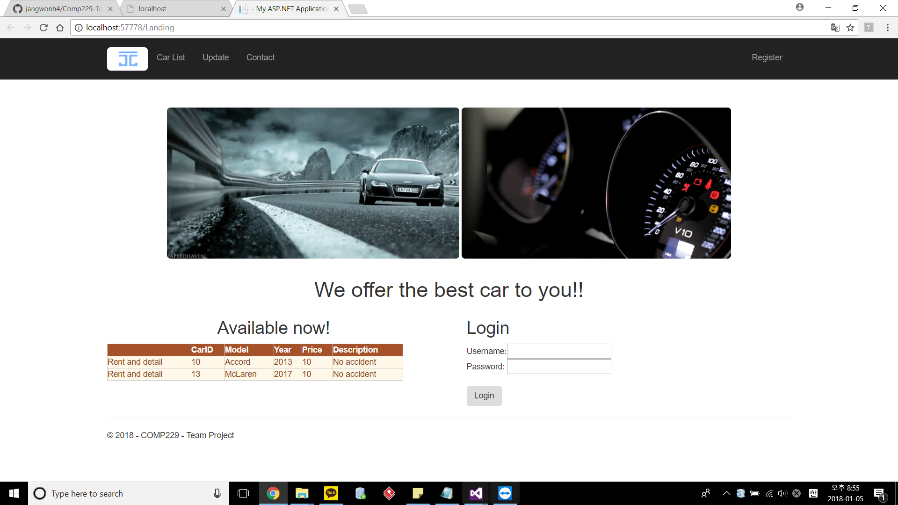

* Customer page

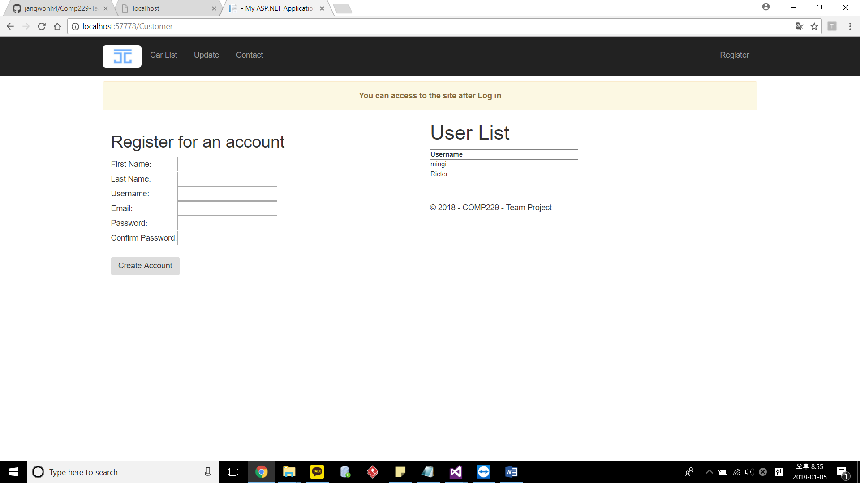

* Car List Page

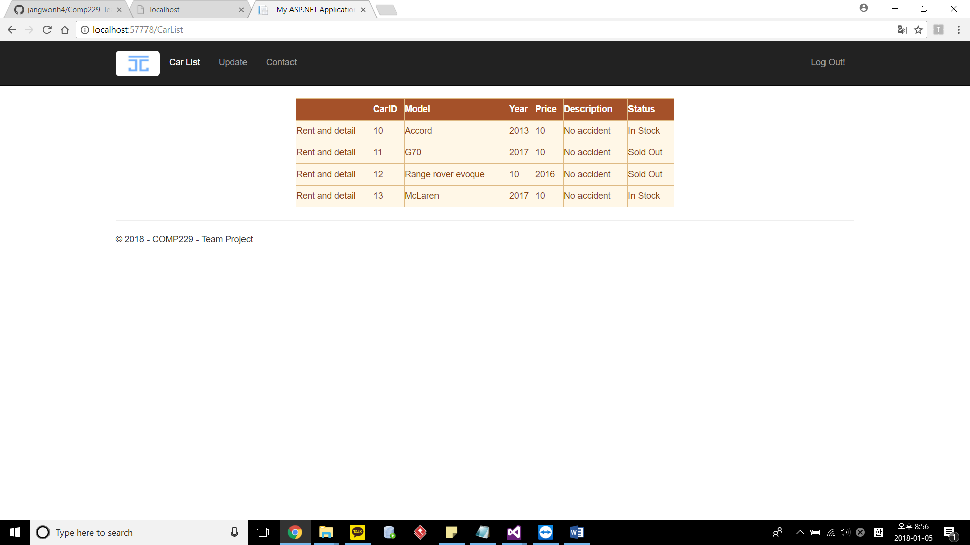

* Update Page

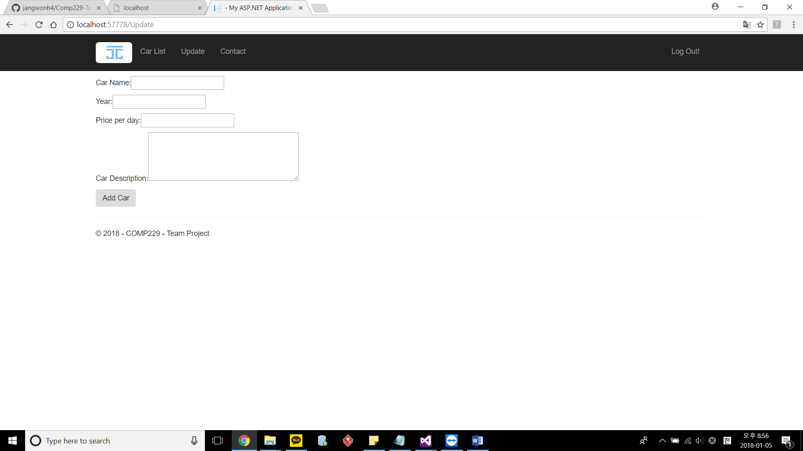

* Car Detail for rent page

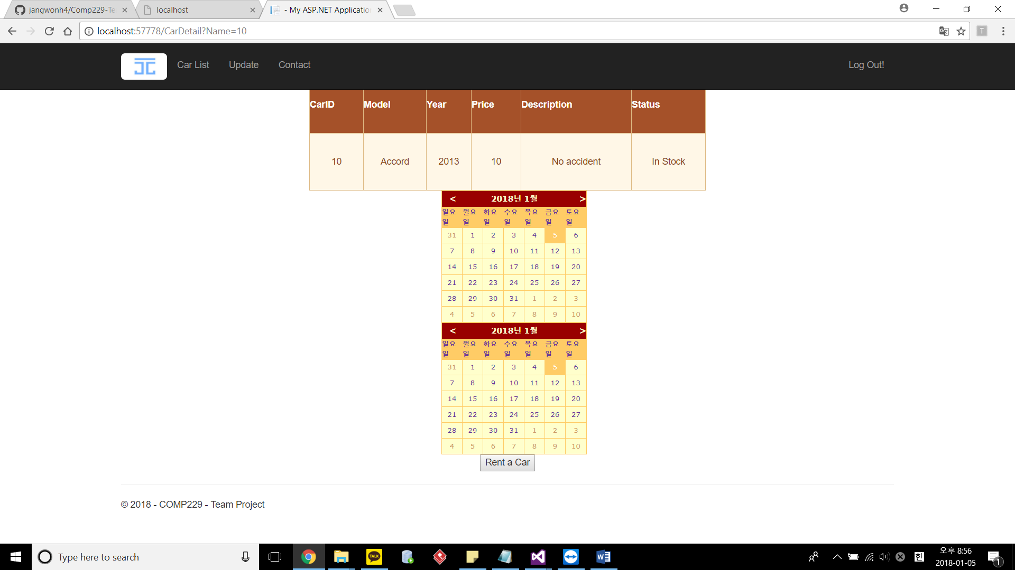

* GitHub : https://github.com/jangwonh4/Comp229-TeamAssign.git

